Assignment 1
Madeleine Rodriguez

Name of ethernet interface on lab machine: enx0c37965f8a24

No packets captured unless the raspberry pi was interacted with (eg pwc causes three packets to be captured- two SSH encrypted packets from server and client a and a TCP packet).

Capture on network interface of lab machine:
name of interface: enp0s31f6

capturing http traffic: on filter line selected display filter expression. Searched for http and selected HTTP = Hypertext Transfer Protocol and relation ‘is present’
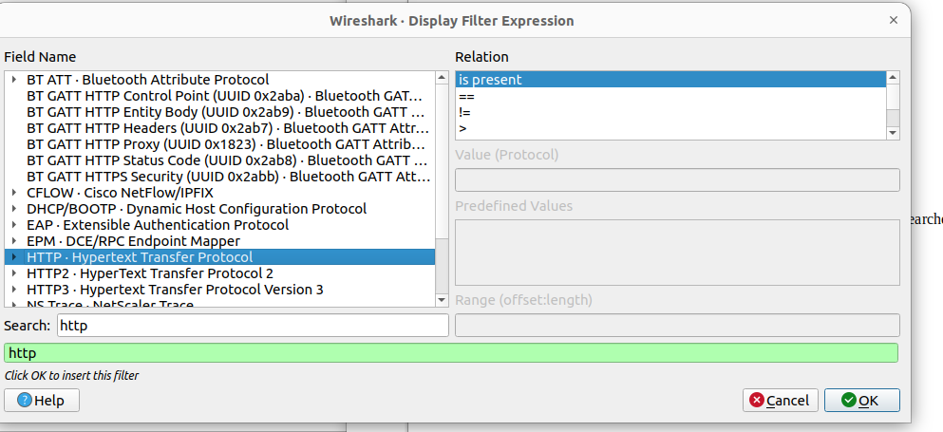
clicked blue error to set filter, which removed all but http protocol captured traffic
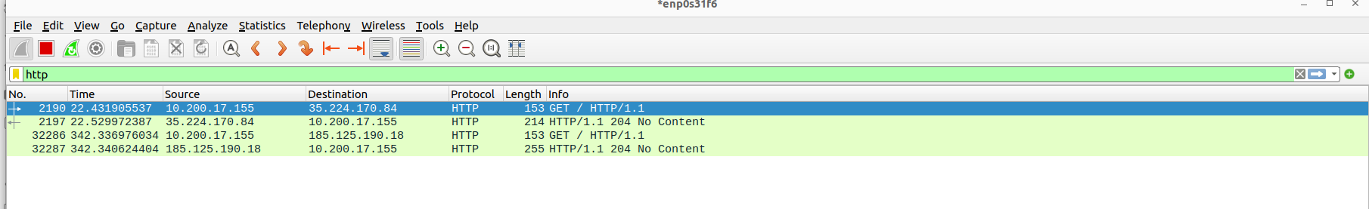

Capturing on the raspberry pi: (captured 10 packets)
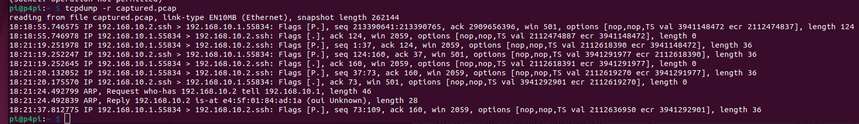

Sending 100 packets from raspberry pi to the lab machine
on lab machine you get ‘sent 1 packets’ messages for every packet
the packets we are sending have UDP protocol and the confirmation messages have SSH/TCP

1. can define a filter to capture only send packets using UDP protocol filter
2. 64 bytes captured with 22 bytes of data, so packet size is 64 bytes
3. UDP

Modified send.py:
